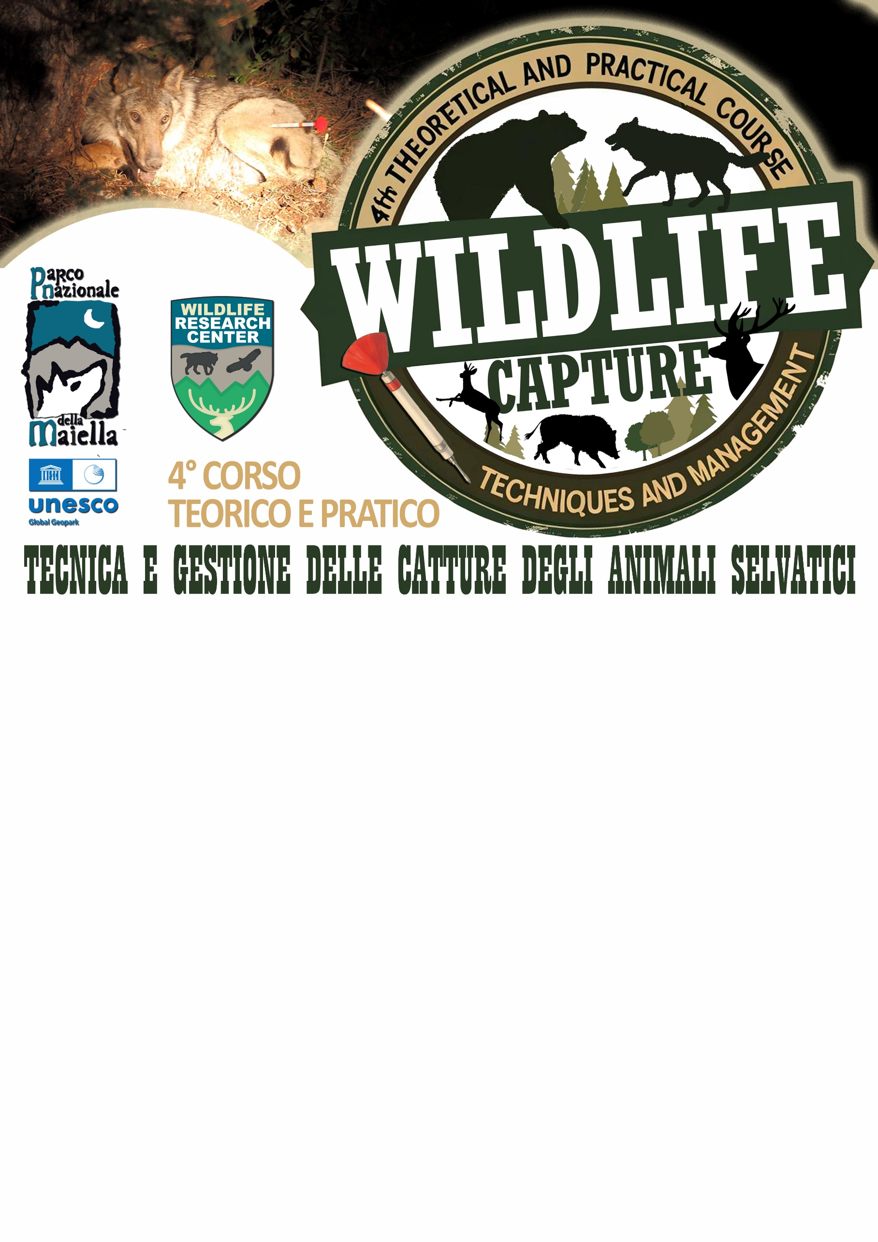

REGISTRATION REQUEST

The undersigned: …………….…………………………………………………………………………………………………………………………….
Born in: ………………………………………………………………………….…………………………………………. (…) on ……/……/…………
Residing in: ………………………………………………………..……… (…) at ………………….……………………, No. … ZIP Code ……
Professional title: ………………………………………………………………………………………….………………………………………………
☐ Public Administration employee at ……………………………………………………………………………………………………………
☐ Freelance professional at …………………………………………………………………………………………..………………………………
☐ Other: ……………………………………………………………………………………………….………………………………………………………

REQUESTS

to participate in the 4th Theoretical and Practical Course “Wildlife Capture Techniques and Management”, organized by the Maiella National Park Authority in Caramanico Terme (PE) at the Wildlife Research Center – Scientific Headquarters, from November 3 to 7, 2025.

DECLARES

to be aware of the need to pay the registration fee of €600 (VAT included), via bank transfer to the following account: IBAN IT 79 A 03069 77841 6152 3749 2342, payable to Soc. Coop. Majambiente a r.l., via del Vivaio, Caramanico Terme (PE), with the reference “REGISTRATION WILDLIFE CAPTURE COURSE 2025”, no later than Friday, October 3, 2025, upon receiving confirmation of admission to the course.

REQUESTS
to receive any communications via:
☐ Phone: (+…...) ………………………………………………………………………………………………….……………………………………
☐ Email: ………………………………………………………………,,,,………………………………………………………………………………

I wish to receive:
☐ INVOICE ☐ RECEIPT/FISCAL DOCUMENT

Invoice details (if applicable):
………………………………………………………………………………………….………………………………………………………………….
Municipality of …………………………………………………… (…) at ………………………………, No. … ZIP Code ………..…
VAT No. ……………………………………………………..…… PEC (Certified Email) ……………….…………………………………
Billing code ………………………………………………………………………………………………………………..…………………………

Important Notice: The Italian-to-English simultaneous interpretation service will be activated only if at least 10 registered participants require it.

Attached: Curriculum Vitae

